Exercise 8:
- SELECT DISTINCT salary FROM employee_data ORDER BY salary DESC; 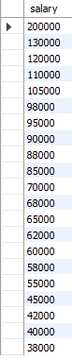
- SELECT COUNT(DISTINCT f_name) AS unique_first_names FROM employee_data;
